**Role Based Evidence**

1. Project Manager

In this MVP project, I served as the Project Manager, responsible for overseeing the entire development process, ensuring smooth collaboration, and maintaining an efficient workflow using the Scrum framework. My primary focus was on coordinating tasks, organizing meetings, and facilitating effective communication among team members to successfully deliver the Tech Master online course shopping platform.

Key Contributions and Responsibilities

Throughout the development of our MVP, I made the following significant contributions:

A. Sprint Planning and Task Management

* Created and managed the Sprint Backlog, ensuring tasks were clearly defined and assigned based on team members’ expertise.
* Structured development into sprints, ensuring achievable milestones and continuous progress.
* Used Agile project management tools to track tasks and deadlines efficiently.

B. Team Communication and Meetings

* Organized and led regular team meetings to align goals, discuss progress, and resolve blockers.
* Facilitated Scrum stand-ups to ensure continuous feedback and transparency among developers.
* Maintained effective communication with all stakeholders, ensuring clarity on project objectives.

C. Documentation and Workflow Coordination

* Managed and documented project workflows, making sure every stage was well-defined.
* Created a Sprint 1 Report, outlining our progress, roadblocks, and next steps.
* Uploaded and maintained project resources in a shared repository for easy accessibility.

D. MVP Demonstration and Video Contribution

* Played an active role in the MVP demonstration video, explaining project management strategies and how the Scrum methodology streamlined development.
* Helped coordinate the video recording and structure, ensuring all team members presented their contributions effectively.
* Ensured the final version was properly edited and uploaded to YouTube, meeting assessment requirements.

Challenges and Solutions

While working as a Project Manager, I encountered several challenges:

* Task Distribution Complexity: Ensuring fair and efficient task delegation was challenging. I overcame this by continuously adjusting the backlog based on developer feedback and workload.
* Meeting Coordination: Aligning team members’ schedules was difficult, so I established pre-scheduled recurring meetings and used asynchronous communication when needed.
* Deadline Management: Keeping developers on track was crucial, so I closely monitored progress and sent reminders to maintain momentum.

By proactively addressing these challenges, I ensured that our MVP stayed on course while maintaining a collaborative and productive work environment.

**For brief evidence l have shared screenshots of Sprint backlog**

Monday backlog:

<https://wlv738675.monday.com/users/sign_up?invitationId=49509258774735440000&inviter_id=73140008&source=invite-modal>

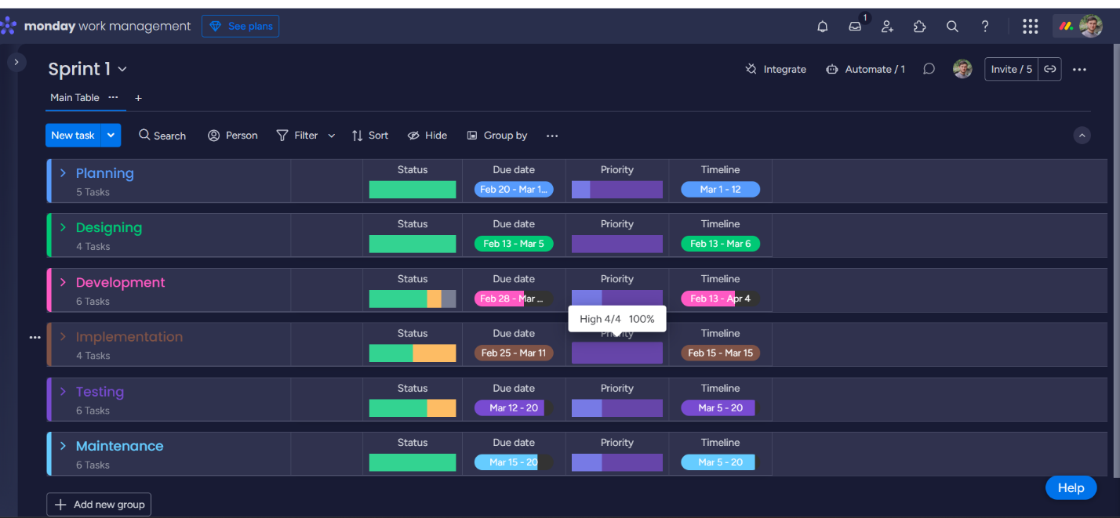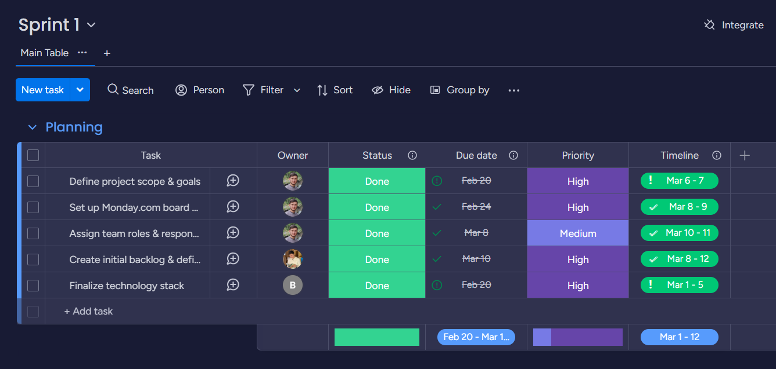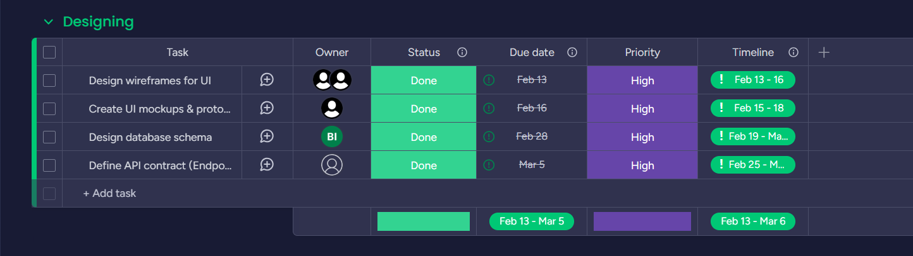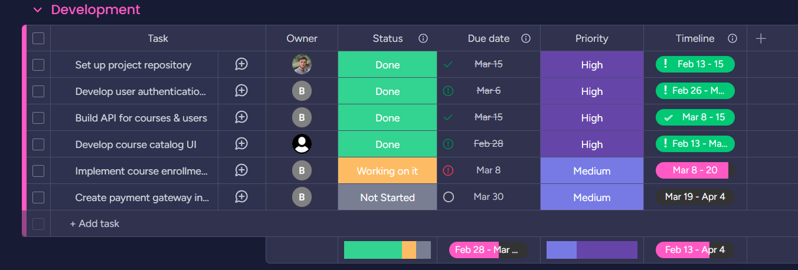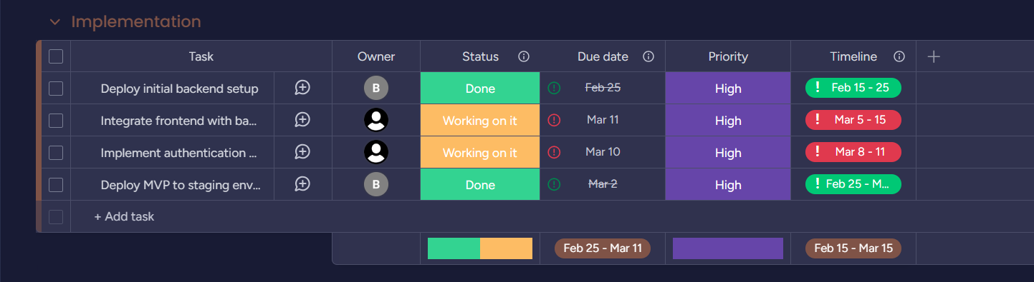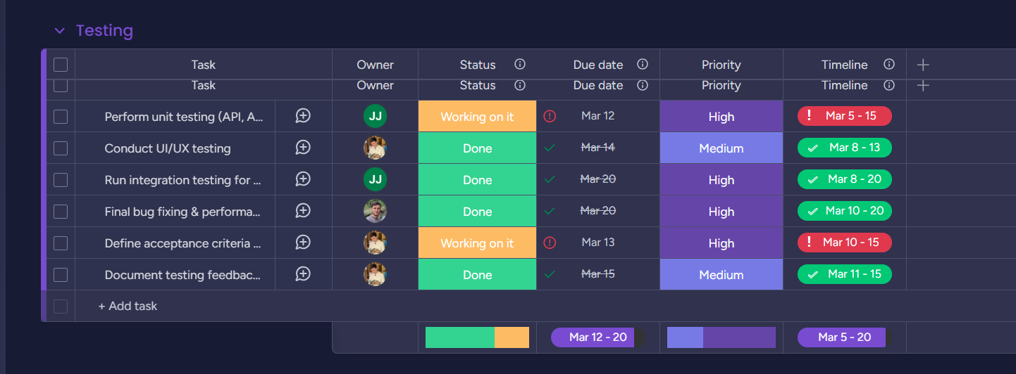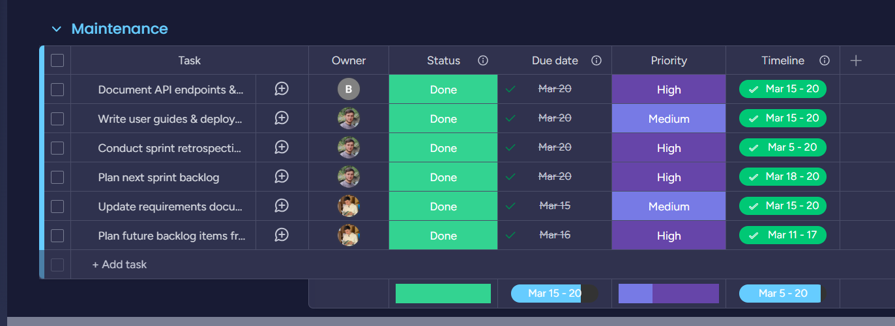

This is Attendance which l got in meetings: <https://quickest-tellurium-11c.notion.site/Team-Meeting-Attendance-Register-1bb36f46aca08046bcf9ccd497add375?pvs=4>

**Risk Assessment Report for Tech Master MVP**

**1. Introduction**

As the **Project Manager** for the **Tech Master** online course shopping platform, I conducted a **risk assessment** to identify potential obstacles that could impact our project's success. This report outlines key risks, their impact, and the mitigation strategies implemented to ensure smooth project development.

|  |  |  |  |
| --- | --- | --- | --- |
| Risk Category | Description | Impact Level | Mitigation Strategy |
| Missed Deadlines | Developers struggling to complete tasks on time due to workload or unforeseen challenges. | High | Implemented strict **Sprint planning**, set **realistic deadlines**, and held **regular check-ins** to track progress. |
| Communication Gaps | Lack of clear communication among team members leading to misunderstandings. | Medium | Organized **weekly stand-up meetings**, used a **shared task management tool**, and encouraged **real-time updates**. |
| Technical Challenges | Unforeseen bugs, integration issues, or technical difficulties slowing down progress. | High | Developers worked in **small iterations**, conducted **frequent code reviews**, and used **debugging sessions** to resolve issues quickly. |
| Scope Creep | Additional feature requests increasing workload and delaying project completion. | Medium | Defined a **strict MVP scope**, maintained a **feature backlog**, and prioritized **essential functionalities**. |
| Team Availability Issues | Scheduling conflicts or team members missing meetings. | Low | Established **pre-set meeting times**, documented discussions, and used **asynchronous communication** to keep everyone updated. |

**Conclusion**

By proactively identifying and addressing these risks, I ensured the **Tech Master MVP** development stayed on track, with minimal disruptions. Effective planning, continuous communication, and a structured risk management approach helped us successfully navigate challenges and meet our project goals.